Graph the following linear equations.
- y = $\frac{-3}{4}x+6$
- y = 3x – 5
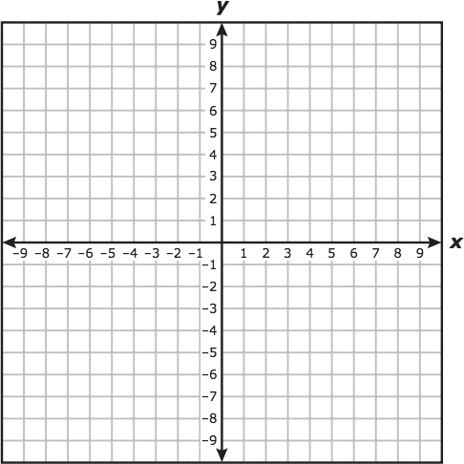
Write the following linear equations with the given information. Write them in slop-intercept form (y = mx + b).

x | y
-2 | 5
-1 | 3
0 | 1
1 | -1

x | y
2 | 12
4 | 13
6 | 14
8 | 15

- The Body Mass Index (BMI) is a measure of body fat using height and weight. The heights and weights of twelve men with normal BMI are given in the table.
Height (in.) | Weight (lb.)
62 | 115
63 | 124
65 | 120
67 | 134
67 | 140
68 | 138
68 | 144
68 | 152
69 | 147
72 | 155
73 | 168
73 | 166
- Make a scatter plot comparing the height in inches to the weight in pounds.
- Draw a line of best fit for the data and find the equation of the line in slope-intercept form (y = mx + b).
- Use your graphing calculator and linear regression to find the line of best fit.
- Use both equations to predict what the height of a man will be that is 188 pounds.
- Use both equations to predict the normal weight for a man who is 84 inches tall.
- Interpret r. Which equation should you use to make predictions?
Review. Follow the directions.
- Find the mean, median and mode of the following data and determine which is the best measure of central tendency.
2, 3, 4, 2, 3, 5, 7, 8 , 1, 5, 2, 3, 4, 6, 7, 1, 1, 3, 4, 5, 2, 6, 7, 8, 9, 11, 1, 12, 14, 15

- Solve the systems of equations. Kelsey and Emma babysit after school to earn extra money. Kelsey made $52 by charging $10 per hour and $4 per child. Emma made $67.50 by charging $15 per hour and $2.50 per child. How many hours and how many children did each babysit? (Define variables, write equations, and then solve.)

- Solve the following quadratic equation. 3x² + 10x = 15.

