Solve the system of equations by graphing.
- y = 4x + 3
y = -x - 2
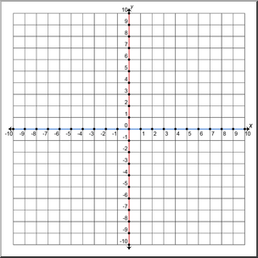
- y = $\frac{-1}{2}x-1$
y = $\frac{1}{4}x-4$

Solve the system of equations by substitution or elimination.
- y = 4x – 9
y = x – 3

- 4x + 2y = 10
x – y = 13

Solve the following problem.
- The school that Stefan goes to is selling tickets to a choral performance. On the first day of ticket sales the school sold 3 senior citizens tickets and 1 child ticket for a total of $38. The school took in $52 on the second day by selling 3 senior citizen tickets and 2 child tickets. Find the price of a senior citizen ticket and a child ticket.

Review
Simplify the following expressions. Rewrite all exponents positive.
- ${\left(\frac{x^{-2}y^{4}}{y^{-1}x^{3}}\right)}^{-2}$

- (n³)³ ⋅ 2n⁻¹

Solve using any method.
- 3x² + 6x – 42 = 0

